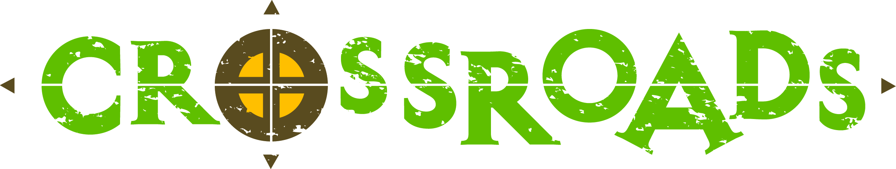

Good Shepherd Lutheran BLAST Covenant

Defining Verse: 1 Peter 4:8-11 (NIV)

Above all, love each other deeply, because love covers over a multitude of sins. (v. 8)

● We will treat others with respect and kindness
● We will forgive one another
● We will be on time to meetings/events/devotions
● We will look out for one another, helping and encouraging as needed
● We will make our group a safe place for others

Offer hospitality to one another without grumbling. (v. 9)

● We will travel in groups of 3 or more at all times
● We will stay positive and not grumble at others
● We will be team players, helping on the first time
● We will be courteous to others, both in our group and outside it
● We will respect our roommates by keeping the room clean and respecting the
room schedule (bathroom times, bed times, etc)

Each one should use whatever gift he has received to serve others, faithfully administering God’s grace in its various forms. If anyone speaks, he should do it as one speaking the vary words of God. (v. 10-11)

● We will use words that build one another up, not tear down, even in jest
● We will keep confidentiality
● We commit to telling others about our experiences after the event
● We will be honest and respect the thoughts of others
● We will speak the truth in love rather than criticize others
● We will use clean language
● We will not exclude others through inside jokes or by forming cliques
● We will use appropriate voices – especially with other outside groups

If anyone serves, he should do it with the strength God provides. (v. 11)

● Leaders will get the whole story before making conclusions
● Leaders will make decisions with the good of the group in mind
● We will abide by the decision of the leaders, even if we don’t like it
● We will be flexible when schedules have to change
● We will be proactive in looking for opportunities to help others
● We will follow-through and do things right the first time
● We will pray for others and do kind things for them
● We will look for opportunities to spread God’s Word

So that in all things God may be praised through Jesus Christ. (v. 11)

● We will be wholly present, refraining from cell phones/texting and headphones
except for call our families at designated times and sleeping
● We will keep our bodies free of illegal substances such as drugs and alcohol
● We will look for something to take home and apply to our lives
● We will refrain from intimate physical contact with others, including sitting on
laps, laying on one another and holding hands
● We will look for opportunities for positive physical contact such as hugs and pats
on backs

To him be the glory and the power for ever and ever. Amen.

This is what the LORD says: “Stand at the crossroads and look; ask for the ancient paths, ask where the good way is, and walk in it, and you will find rest for your souls.”
(Jeremiah 6:16)

____________________________________ _______________

Youth Signature Date

____________________________________ _______________

Parent Signature Date

____________________________________ _______________

Youth Director Signature Date

